

**Ahsanullah University of Science & Technology**

**Department of Computer Science & Engineering**

**Project Report on**

**Hotel Management System**

**(Hotel Paramount)**

**Course Title: Database Lab**

**Course No: CSE 3104**

**Submitted to-**

**Mr. Nazmus Sakib**

Assistant Professor

AUST

**Mr. Munshi Rejwan Ala Muid**

Lecturer

AUST

**Prepared By-**

**Group Members-**

1. Name: Raisa Rokib

ID : 18.02.04.123

2. Name: Jarin Anjum Zuthi

ID : 18.02.04.135

**Project Name:** Hotel Paramount

**Description:** Hotel Paramount is a hotel management system. This is a proper management system for a hotel. Here all the details is described according to the java class:

**UsersRegistration.java:**

There will be some admins or we can say receptionists. New admin has to enter or signup to the system through any older user admin. So the software of this hotel will be secured.

**AddEmployee.java:**

The admin can add all the employees like front desk clerks, chefs, housekeeping, kitchen stuffs, room service, manager etc. and collect all their data.

**AddDrivers.java:**

The admin can add all the drivers and their information. As the hotel is distributing the transport service to the customers.

**AddRoom.java:**

The admin can add all rooms and their conditions.

**Reception.java:**

All the information is gathered here. Admin can see them through the buttons.

**NewCustomer.java:**

The admin will add the guests through the form with the information.

**CustomerInfo.java:**

All the data of the guests who are staying in this hotel will be fetched here from the database.

**Room.java:**

All the data of the “room” table will be fetched here from the database.

**SearchRoom.java:**

The admin can search any of the rooms according to bed type and also availability. So that they can inform the guests at the time of booking.

**UpdateRoom.java:**

If any customer tells his room number and complain that his room is dirty, the admin can edit that so that the room service is active.

**Employee.java:**

All the data of the “employee” table will be fetched here from the database.

**ManagerInfo.java:**

As the manager has to observe all the stuffs, so there is a separate table of manager as the hotel often needs all the information of the manager. All the data of the managers from “employee” table will be fetched here by using ‘where’ clause.

**Department.java:**

All the data of the “department” table will be fetched here from the database.

**PickUp.java:**

The admin can see all the available drivers according to the car type and can inform the guest.

**UpdateCheck.java:**

Here for the each guest id, their date of checked in and pending amount will be shown.

**CheckOut.java:**

Whenever a guest will checkout, all their data will be deleted from the database.

These are some main java classes. There are other basic classes like login, signup, user’s details etc. Also we have added some more queries through the queries.java class. We have used the queries like INSERT, UPDATE, DELETE, JOIN, SELECT, aggregate functions, sub query, order by, having, where clause etc. in our project.

In this project we have used open-source Java-based framework in NetBeans. For managing data we have used a relational database management system (RDBMS). Here we have used Microsoft SQL Server 2019.

**ERD**

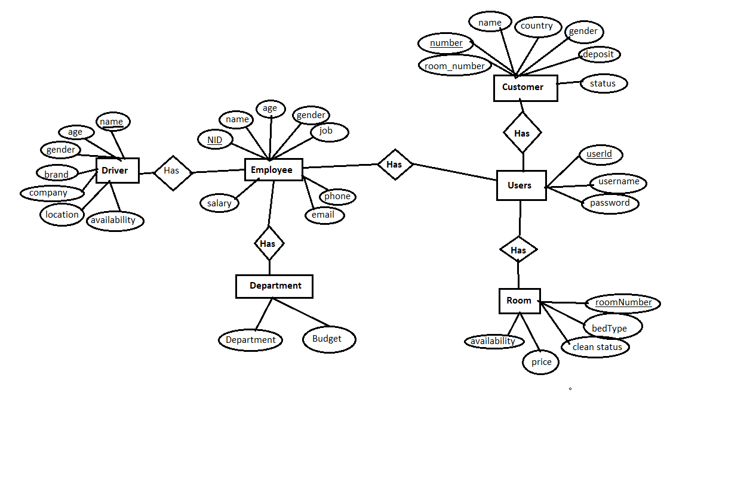

**Relational schema**

